Student Name:
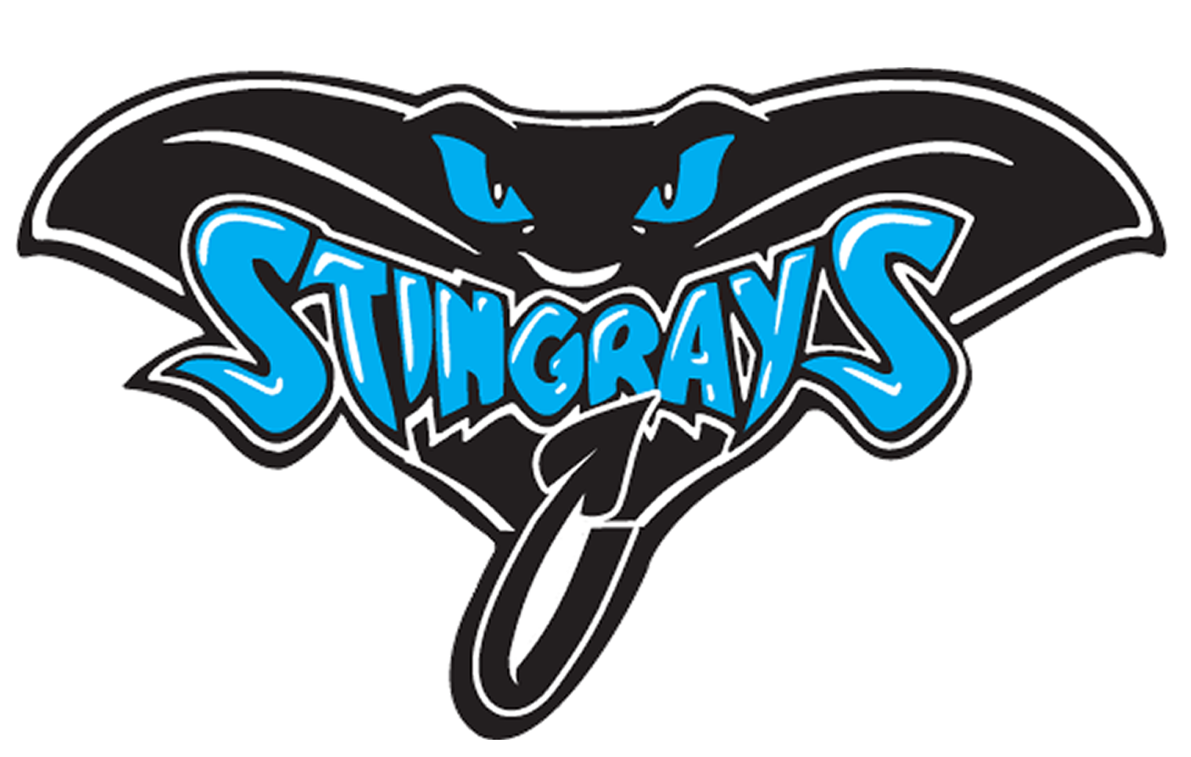
John M. Sexton Elementary School
“Where students are becoming great readers, writers, mathematicians, and scientists.”
Family/Student/Teacher Compact 2023-2024

Grade:

Teacher Name:

As a Scholar, I agree to carry out the following “RAYS” responsibilities:
R
espect yourself and others, have a growth mindset, and always use respectful language.
A
ct Responsibly by working together as a team to keep our campus safe and clean.
Y
our Best Is Expected by arriving on time, in uniform, with materials and complete their work.
S
elf-Control in maintaining a safe environment by keeping your hands, feet, and objects to yourself.

Student Signature

Revised 8/2/2023

As a Parent/Guardian/Family Member, I agree to carry out the following “RAYS” responsibilities:
- Provide a home environment that supports and encourages my child to be their BEST self through reading, studying and learning.
- Communicate regularly with my child's teachers and actively participate in their learning by volunteering and attending meetings, events, and activities.
- Show respect and support for my child, their teachers and the school.
- Ensure my child arrives to school daily, on time, in uniform, and with needed materials.

Parent Signature
As an Instructional Staff Member, I agree to carry out the following “RAYS” responsibilities:
- Provide a welcoming and safe learning environment for all scholars.
- Enforce school and classroom rules equitably and consistently, while being a positive role model in my own words and actions.
- Provide high-quality and engaging instruction while setting high expectations for scholars.
- Maintain an open line of communication with all scholars and their families.

Teacher Signature

I reviewed my goals with my teacher and family during conferences this year.

Conference #1: ____________________
Date

______________ ______________
Family Initials Teacher Initials

Conference #2: ____________________
Date
______________ ______________
Family Initials Teacher Initials

